Poznań, 07.03.2024

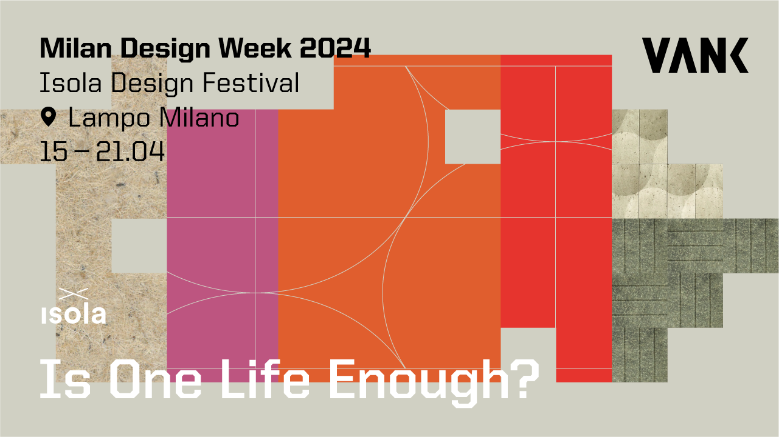

Visit VANK in Lampo Milano during Milan Design Week 2024

VANK is thrilled to announce its debut participation in Milan Design Week 2024, scheduled from April 15th to 21st. Our sustainable designs will be displayed in the group exhibition Is One Life Enough? situated in a revitalized venue with green DNA - Lampo Milano, located in the vibrant Isola district. We explore the idea of energy as an element integral to innovative design, just as solar energy is essential for plant growth in the process of photosynthesis. This synergy between nature and creativity paves the way for new opportunities in sustainable development and creative approaches to design.

During the Isola Design Festival, over 320 global designers, studios, creatives, and manufacturers will showcase their work in numerous venues, encompassing three main centers, notably, for the first time, the Lampo event venue situated at Via Valtellina 5. Lampo Milano is a new urban redevelopment project with green DNA spanning an area of 40.000 sqm within the historic railway yard, Scalo Farini. Is One Life Enough? features a curated selection of collectable pieces and market-ready products crafted using sustainable materials and circular methods. It sparks a dialogue on the countless possibilities within a human, product, and material lifetime while showcasing ways to infuse new life into products designed for a single life cycle.

VANK exhibition explores the idea of energy as an element integral to innovative design, just as solar energy is essential for plant growth in the process of photosynthesis. Through this process, plants absorb carbon dioxide from the atmosphere and convert it into biomass, which we can then use in various creative and manufacturing processes. The greater the number of products featuring renewable plant-based raw materials, the lower the dependence on oil and the carbon footprint. This synergy between nature and creativity paves the way for new opportunities in sustainable development and creative approaches to design.

Guests visiting the Lampo space and the VANK exhibition can anticipate encountering inspiring trends and innovative circular design concepts.

VANK_CUBE is a modular cube system crafted from biomaterials, that makes it possible to set up a truly green workspace in any environment and adapt it to the changing needs of its users. The designs fosters creative thinking and a culture of collaboration.
The CUBE elements are manufactured using innovative biocomposite made from flax and hemp — fast-growing renewable plants that absorb much more CO2 than trees. The CUBE by Anna Vonhausen secured the German Innovation Award 2023, earning the 10th spot in Office Roxx magazine's prestigious TOP100 list, and emerged as a finalist in the Mixology North 2023 competition.

VANK’s state-of-the-art acoustic walls panels are a combination of pro-environmental values and every individual’s need for wellbeing. Our proprietary technology makes use of renewable bio-based or recycled materials, and produces shapes that provide sound attenuation and make rooms soundproof. Designers have the freedom to configure panels of various shapes, allowing for the creation of imaginative wall finishes in both public spaces and homes. At Lampo in Milan, these panels will be showcased as ready-to-purchase acoustic reliefs. The project is a finalist for the German Sustainability Award 2022 and has been honored as the winner of both the Green Product Award 2022 and the Iconic Awards 2022.

By utilizing plant-based raw materials, VANK minimizes the reliance on petroleum-based substances, thereby contributing to the circular economy and the combat against the climate crisis.
The VANK_BIO biomaterial has a negative carbon footprint. Bio-based resources - such as flax and hemp - absorb CO2 from the atmosphere during their growth phase and convert it into biomass through photosynthesis. The quick growth of hemp, i.e. up to even 4 metres in 100 days, makes it one of the fastest CO2 absorbers out there. A hemp field can absorb up to 15 tonnes of CO2 per hectare (according to IPCC reports).
The Milan event also marks collaboration with Kvadrat, a renowned brand recognized for its high-quality premium fabrics, which we will showcase on our circular soft seating collection. The soft-touch boucle Elle in sunset colors will be featured on the VANK_LONG lounge chair, known for its distinctive line of semicircular cushions.
VANK_LONG is a line of eye-catching industrial-style furniture, that draw inspiration from Bauhaus minimalism. The seat, resting on flexible upholstery straps undoubtedly, guarantees a special user experience and a high level of well-being. This sustainable collection makes use of textile industry waste, limited-edition End Of Series natural leather dead stock, and organic latex filling. The design allows easy disassembly and recycling of components after use. The collection is modular - fasteners and connectors make it possible for the user to use armchairs to put together sofas as well as endless rows of seats. Their base is a black metal frame that emphasises their industrial character.
VANK_LONG has been honored as the winner of the Iconic Awards 2024 and will also be showcased in Milan at the digital exhibition hosted by the German Design Council. The exhibition will take place at the Amy-d Arte Spazio gallery in the Brera district, located at Via Lovalio 6, from April 16th to April 21st.

Visit us in Milan!

LAMPO MILANO
Via Valtellina 5, Isola
20158 Mediolan

Free entrance:
Mon. | 14:00 -19:00
Tues. – Sob. | 10:00 -19:00
Sun. | 10:00 -15:00

IMAGES

WHAT THE VANK

VANK is a Polish team of architects, engineers, and artisans. We create furniture. Objects. Tangible signs in space. Items designed intelligently, with respect for the natural environment, and manufactured using the latest technologies. We believe in a circular economy model that limits the consumption of natural resources, reduces the amount of waste generated, and increases the use of biodegradable, renewable, and recyclable materials. We’re all about high quality, taking responsibility for what we do and make, and making our products last as long as possible.

www.vank.design | Linkedin | Facebook | Instagram | YouTube | Pinterest

For media inquiries and additional information, please contact:

Natalia Sochacka, Marketing & Communications Manager,
natalia.sochacka@vank.design, + 48 601 553 221

