Poznań, 13.03.2024

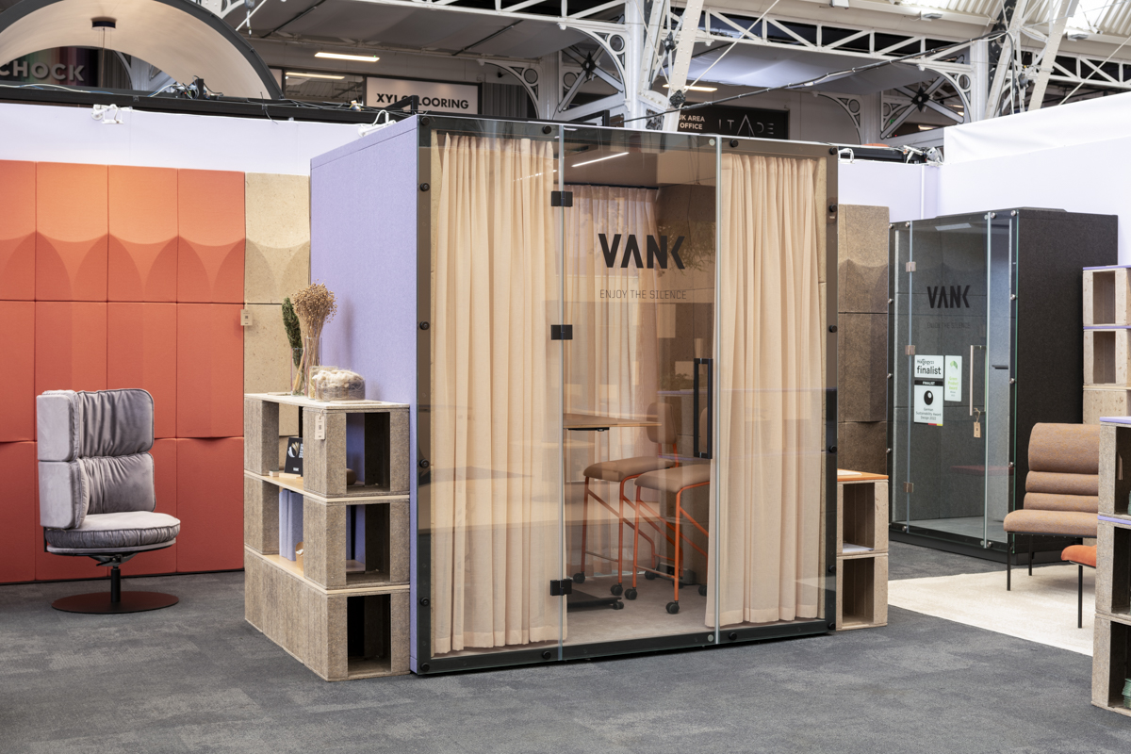

VANK circular design at the Workspace Design Show 2024 in London

We participated in the Workspace Design Show for the second time on 27-28 February 2024. The event was held at London's prestigious Business Design Centre, which is known as the UK's premier workspace interiors exhibition. The Workspace Design Show attracted top architects, designers, occupiers, developers, consultants, coworking companies, and fit-out firms from England, Wales, Scotland, and Ireland, as well as cities such as London, Manchester, Leeds, Cardiff, Birmingham, Edinburgh, and Belfast.

It was a great pleasure to meet with clients in London and discuss our sustainable solutions for creating green offices. We are thrilled that VANK design has received such a positive response. Visitors to the VANK stand were captivated by our trend-setting and innovative circular design concepts tailored for employee well-being. This includes the finalists from the esteemed 2023 Mixology and Mixology North awards. We presented solutions such as acoustic wall panels made from biomaterial or upholstered rPET material, which created colorful acoustic reliefs. It is worth noting that the alpha coefficient for the VANK panels is 0.9, indicating Class A sound absorption.
Additionally, we unveiled a stunning range of furniture designed to complement our acoustic pods and wall panels, enhancing the functionality and aesthetics of meeting and lounge areas.

An exciting highlight of the event was the launch of our partnership with Kvadrat, renowned for its exquisite fabrics. We were proud to feature Kvadrat fabrics in our circular soft seating collections, including the Arda fabric showcased on the VANK_LONG collection with a distinctive line of semicircular cushions draw on Bauhaus minimalism, and the Avalon velour displayed on the VANK_RING collection, distinguished by its characteristic rushing.

For our soundproof booths, we used transparent, unicoloured curtains - Daybreak designed by the acclaimed Patricia Urquiola. The Daybreak curtains, with their tactile irregularities and natural linen-like appearance, enhance privacy, control acoustics, manage light, and contribute to the overall aesthetic and ambience of the pods.

Read the article on 15 functions of acoustic pods

The CUBE biomaterial system was shown in the form of shelving, desks, seating and counters. During the networking evening, the guests of the event could experience the versatility and mobility of the VANK_CUBE collection. Together, we rearranged the coworking set into an event configuration that included a high table for standing meetings.

During the Workspace Design Show in 2024, VANK showcased innovative, sustainable and aesthetically pleasing solutions to revolutionize office space design and enhance the working environment.

IMAGES

Exhibited collections:

VANK_BOX

Thanks to the special design and the use of sound-absorbing materials, VANK acoustic pods effectively block outside noise and suppress the sound generated inside. The 3D panels on the internal and external walls of the pods act as diffusers to break up sound waves, bringing wellbeing to the office. They can be made of a biocomposite or non-woven rPET — grey or upholstered. The pods feature a safety glass door and come with a ventilation system, energy-efficient LED ceiling lighting, and a sound system. The pod is also available in a mobile version — on wheels.
Soundproof booths will work well not only in office environments but also at event venues, in hotels, in public office buildings, and at airports.
A winner in Iconic Awards 2022 (German Design Council). A finalist in Mixology 2023.

VANK_PANEL

VANK’s state-of-the-art acoustic walls and panels are a combination of pro-environmental values and every individual’s need for wellbeing. Designed in line with sustainability principles, they contribute to the development of circular economy. Our proprietary technology makes use of renewable, recycled, and bio-based materials, and produces shapes that provide sound attenuation and make rooms soundproof. 3D panels act as diffusers to break up sound waves, bringing wellbeing to the office. They can be customized by designers to become creative wall finishes or serve as desk dividers. Mobile walls separate workstations from each other, organise clearly defined zones ready for change, and create spaces to relax and ease the mind. A finalist in German Sustainability Award 2022. A winner in Green Product Award 2022.

VANK_CUBE

VANK_CUBE is a modular cube system that makes it possible to set up a truly green workspace in any environment and adapt it to the changing needs of its users or the organisation. The CUBE cube is manufactured using innovative biomaterial made from flax and hemp — fast-growing renewable plants that absorb much more CO₂ than trees. As plant-based raw materials are its core components, it minimizes the use of synthetics and contributes to the combat against climate change. The designs fosters creative thinking and a culture of collaboration. It also lets individuals working remotely do their thing in a natural setting. A finalist in Mixology North 2023. Awarded with German Innovation Award 2023.
Design: Anna Vonhausen

VANK_LONG

VANK_LONG is a line of eye-catching industrial-style furniture designed with rest and relaxation in mind. The lounge armchair and footrest with a distinctive line of semicircular cushions draw on Bauhaus minimalism. This circular collection is about sustainability in the first place. It makes use of textile industry waste, limited-edition End Of Series natural leather dead stock, and organic latex filling. The design allows easy disassembly and recycling of components after use. The collection is modular - fasteners make it possible for the user to use armchairs to put together sofas as well as endless rows of seats.
LONG is designed for relaxation, waiting, and meeting areas where first impressions matter — in offices, hotels, and other public facilities, but also for home offices and living rooms. It fits perfectly into classic, minimalist or loft environments. Awarded with Iconic Award 2024 (German Design Council).
Design: Anna Vonhausen

VANK_RING

VANK_RING is a family of comfortable lounge chairs, office chairs, sofas, barstools, and poufs, which will make a great addition to minimalist, boho, and vintage style office environments. RING will be an excellent choice for common spaces in the office, reception areas, foyers, and cafés.
The trademark of the series is its bold, theatrical lines, a modernist base resting on a circular form, and a distinct rushing of the fabric. The solution has been created with sustainability in mind: its design makes it possible for its components to be recycled after use and its seat contains industrial polyurethane foam waste. The collection includes also coffee tables and high tables for meeting areas and a desk for home office use. Awarded with Iconic Awards 2022 (German Design Council).
Design: Anna Vonhausen

WHAT THE VANK

VANK is a Polish team of architects, engineers, and artisans. We create furniture. Objects. Tangible signs in space. Items designed intelligently, with respect for the natural environment, and manufactured using the latest technologies. We believe in a circular economy model that limits the consumption of natural resources, reduces the amount of waste generated, and increases the use of biodegradable, renewable, and recyclable materials. We’re all about high quality, taking responsibility for what we do and make, and making our products last as long as possible.

For media inquiries and additional information, please contact:

Natalia Sochacka, Marketing & Communications Manager,
natalia.sochacka@vank.design, + 48 601 553 221

