Poznań, October 9, 2023

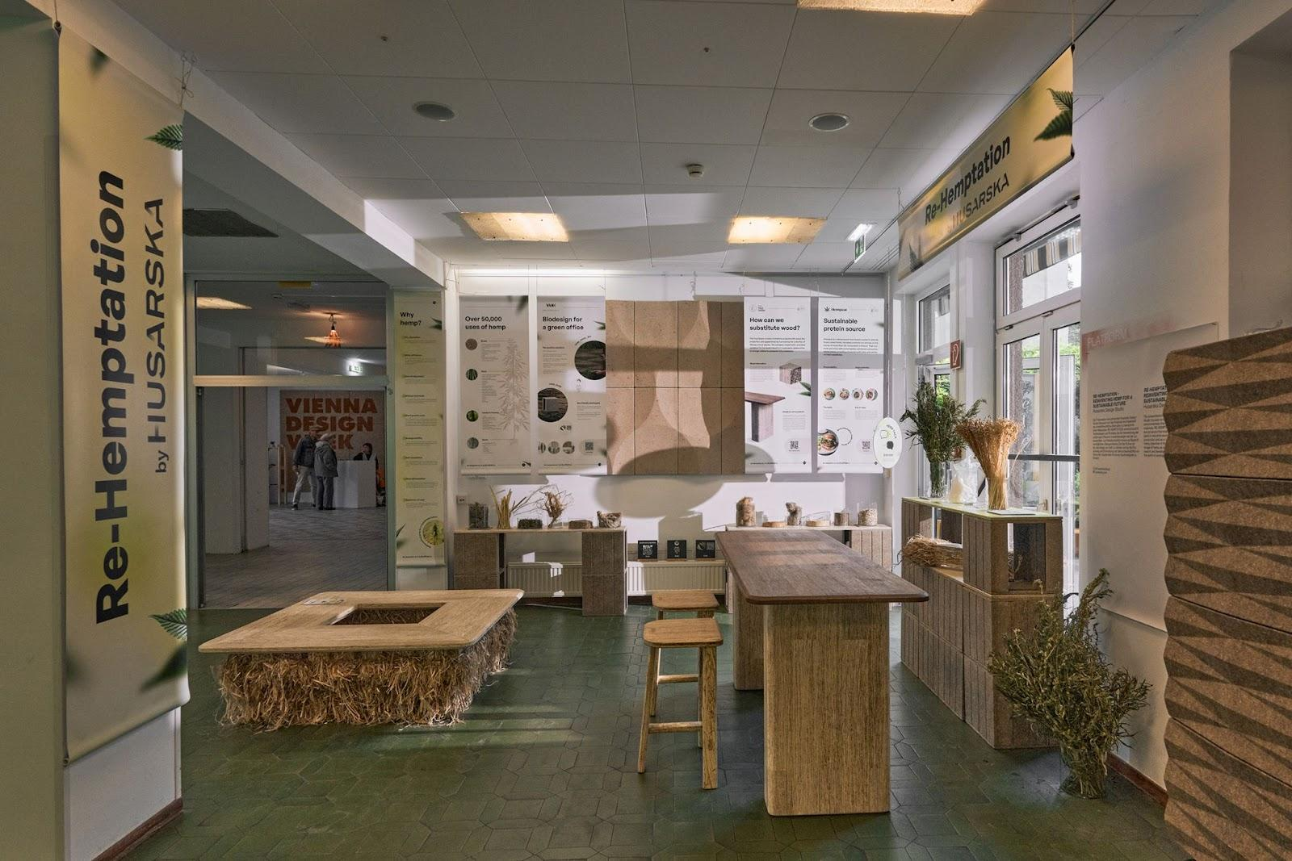
Sustainable materials in future design – Re-Hemptation at VIENNA DESIGN WEEK 2023
During this year's edition of Vienna Design Week 2023, an exhibition titled Re-Hemptation was presented, prepared by Husarska Design Studio and Green Lanes, showcasing the possibilities of using ground-breaking materials created from annual plants in the production of furniture, interior finishing materials, and construction materials, while simultaneously sourcing raw material for other industries such as food, textiles, and nutraceuticals. VANK presented the modular system VANK_CUBE designed by Anna Vonhausen, made from a bio-composite based on flax and hemp.
Re-Hemptation is the answer to the environmental crisis. Annual plants, thanks to their rapid renewable and ecological properties, constitute an ideal raw material for a future based on the principles of sustainable development and circularity. The exhibition was met with an enthusiastic reception and enjoyed high attendance throughout all days of the event. It was not only an opportunity to showcase the first furniture made from hemp lumber, hence a substitute for hardwood by The True Green, but also a space for discussions about environmental responsibility and the green revolution in modern design. The Polish Institute in Vienna and VANK, a furniture manufacturer from sustainable materials, became partners of the event.
Accompanying events - discussions on sustainable design
During Vienna Design Week, two accompanying events took place at the exhibition, during which its creators created an educational platform, presenting the potential of annual plants as alternatives to traditional materials, explaining to participants how innovative products created with their use fulfill sustainable development goals.
The first of these was HEMP TALK (23.09.2023), which was a meeting with designers and creators of the exhibition and discussions about the application of annual plants in modern design and beyond. The second was a panel discussion about the future of hemp, HEMP EVENING (25.09.2023, Polish Institute in Vienna). The discussion about a sustainable future was moderated by Michał Piernikowski from Łódź Design Festival. The panelists included: Jadwiga Husarska-Sobina, Jacek Kramarz from Green Lanes, Hempeat, as well as EIHA - European Industrial Hemp Association, and Natalia Sochacka from VANK. The creators of the exhibition prepared an educational platform during the accompanying events, presenting the potential of annual plants as alternatives to traditional materials, explaining to participants how innovative products created with their use fulfill the goals of sustainable development. Both meetings were accompanied by a tasting of Hempeat - a plant alternative to meat.
Visitors to our exhibition could, among other things, get to know our innovative products replacing solid wood in furniture – says Piotr Pietras, CEO of Green Lanes. Husarska Design Studio designed the first furniture pieces from hemp timber, the Hempden table and the Hempsquare bench, as well as the HempStool stool. Also, our Partner, the furniture manufacturer VANK, presented the modular system VANK_CUBE designed by Anna Vonhausen made from a bio-composite based on flax and hemp. We are delighted that our solutions have been met with such great enthusiasm from designers and manufacturers.
Hemp lumber from The True Green can replace solid wood in furniture and we have showcased the first furniture using this revolutionary material – adds Jadwiga Husarska-Sobina from Husarska Design Studio. The exhibition is an excellent proposition for architects and designers as well as influencers and the general public interested in sustainable development, ecology, and innovations. Soon we will be showing Re-Hemptation at Dutch Design Week, wanting to inspire further exploration and development of innovations based on an ecological approach.
Why is the exhibition titled “re-hemptation”?
The title reveals the deeper meaning of the exhibition, focusing on the rehabilitation and reconstruction of the environment using hemp and promoting sustainable development and biodiversity protection. "Re-Hemptation" combines "re-" (renew, restore) with "hemptation" (from English: hemp). In terms of environmental renewal, the exhibition's name refers to the concept of restoring balance and reconstructing the natural environment through the use of hemp and other fibrous plants. Hemp has the potential to improve soil quality, purify water, and reduce pollution, contributing to ecosystem renewal and reconstruction. The dimension of rehabilitation suggests rehabilitating plants, including hemp, used as ecological alternatives to traditional materials. By promoting these plants, the exhibition emphasizes biodiversity protection and restoration of natural processes and cycles in ecosystems. Regarding sustainable development, "Re-Hemptation" also refers to the idea of sustainable development and a circular economy where innovations and new materials, like hemp, play a key role. The exhibition focuses on exploring the potential of hemp and flax as ecological alternatives to traditional materials while also promoting sustainable economic growth and the protection of biodiversity.

VANK
VANK is a Polish team of architects, engineers, and artisans. They specialize in crafting furniture and other objects that serve as tangible markers in space. Each item is thoughtfully designed, emphasizing respect for the natural environment and leveraging cutting-edge technologies in its creation. With a firm belief in the circular economy, VANK focuses on minimizing the consumption of natural resources, reducing waste, and maximizing the use of biodegradable, renewable, and recyclable materials. Their commitment is evident in the superior quality of their products, their sense of responsibility, and their dedication to ensuring product longevity.
During Vienna Design Week VANK presented a novelty, another sustainable form made of biomaterial - VANK_CUBE designed by Anna Vonhausen. It's a modular cube system that allows the user to configure and reconfigure an eco-friendly workspace in any space and indefinitely. It gives the ability to easily change the interior according to changing needs. A single module looks like a box, but a system of modules can be a desk with a pouffe, a meeting table, a counter, a shelf, a bookcase or a lectern. CUBE is available in two natural colors light- and dark beige and has a storage function - the user can decide whether to expose or cover things on the shelf by changing the direction of the cube. The collection supports creative teams and a culture of collective work, but also allows individualists working independently at a distance to have fun.
JADWIGA HUSARSKA – SOBINA & HUSARSKA DESIGN STUDIO
Experienced project manager and specialist in coordinating the launch of new products. Since 2014, she has been running the Husarska Design Studio in Krakow. She is a graduate and consultant at the Faculty of Industrial Design of the Academy of Fine Arts in Krakow. She studied design at the Lahti Institute of Design in Finland and at MOME in Budapest. She worked as a product development director at Paged Furniture, coordinating the work of design teams and engineers in product implementations for global clients. She designed for Nowy Styl Group, SanSwiss, Apus Sports, Total Fitness Concept, and FlooredMedia (projects for IKEA). She was honored by UNDP with the title "Angel of Social Economy" for supporting the development of the WellDone brand on behalf of the Być Razem Foundation. She has more than 195 successful implementations across various business sectors to her credit. She is the recipient of many Polish and international awards, including 5 RedDot awards, which are considered the "Oscar" in the field of design.
GREEN LANES - the company with a positive impact. In its portfolio, it has independent entities focused on the development of projects and technologies in the industry focused on processing annual plants, including fibrous hemp. Currently, Green Lanes is developing three portfolio companies: The True Green, Green Lanes Proteins, and Hempeat. In 2024, the company plans to go public.
THE TRUE GREEN – the company engaged in processing the stems of annual plants, including hemp and flax. It develops innovative technology and products with properties and appearance similar to solid wood, utilising the potential of fibrous annual plants.
HEMPEAT – the company producing food products, including primarily hemp-based textured protein meat substitutes.
GREEN LANES PROTEINS – the company has developed technologies that allow for the extraction and concentration of protein contained in the by-products of the process of extracting edible oil from hemp seeds. It also conducts a number of R&D activities aimed at improving existing products and creating new ones based on plant protein isolate and concentrate.
EAST HEMP AGRICULTURE It's the agricultural division of Green Lanes that manages cultivation, procures seed material, and provides services for entities cultivating hemp seeds.
LOGOS AND IMAGES:
https://drive.google.com/drive/folders/1Jxj6ua5CrirTij8ziy5coLYdZmT1CiY0?usp=sharing
STATEMENT: All submitted materials are the property of Green Lanes, Husarska Design Studio, and VANK constitute press materials, and have permission for their publication.
PR contact
Natalia Sochacka, Marketing&Communicatios Manager
natalia.sochacka@vank.design, + 48 601 553 221

