Poznań, 14.11.2023

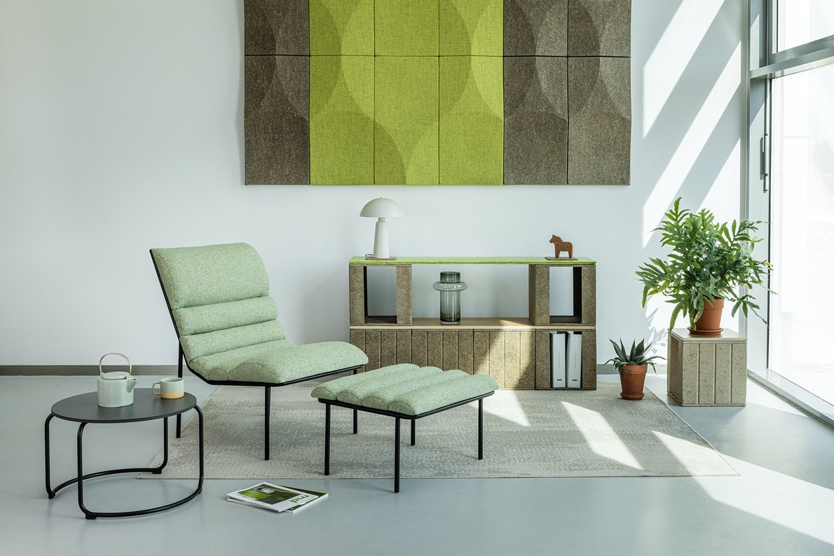

New circular soft seating collection for lounge areas from VANK

New VANK_LONG is a line of eye-catching industrial-style furniture designed with rest and relaxation in mind. The lounge armchair and footrest with a distinctive line of semicircular cushions draw on Bauhaus minimalism. The seat guarantees a special user experience and a high level of well-being. This modular and circular collection is about sustainability in the first place.

The lounge armchair and footrest with a distinctive line of semicircular cushions draw on Bauhaus minimalism. The seat, resting on flexible upholstery straps undoubtedly, guarantees a special user experience and a high level of well-being. A larger cushion located under the knees helps you relax and maintain a healthy posture. The collection is modular - frame fasteners and connectors make it possible for the user to put together sofas, benches, and long rows of seats. Their base is a black metal frame that emphasises their industrial character.

This circular collection is about sustainability in the first place. It makes use of textile industry waste, limited-edition zero waste natural leather dead stock, and organic latex filling. Choosing zero-waste leathers - which also feature some natural imperfections - will be an environmentally and economically sound choice. It reduces demand for new animal hides and translates into significant project budget savings - of even up to 50%. The cushions are filled with organic latex originating from the sap of rubber trees. By using natural latex, we reduce the use of synthetic raw materials and offer a well-breathing and moisture-wicking seat filling. In addition, the feature of a zipper makes it possible to easily remove it from the cushions. Its manufacturing does not use glues. The seat is fixed to the frame so that it too can be easily separated and recycled after use. LONG is also available in fashionable retro recycled fabric. All of the above features combined make an extremely environmentally friendly solution. And this is what sets it apart from other collections in the soft seating category.

LONG is designed for relaxation, waiting, and meeting areas where first impressions matter - in offices, hotels, and other public facilities, but also for home offices and living rooms. It fits perfectly into classic, minimalist or loft environments as well as into Japandi interiors.

Design: Anna Vonhausen
VANK
VANK is a Polish team of architects, engineers, and artisans. We create furniture. Objects. Tangible signs in space. Items designed intelligently, with respect for the natural environment, and manufactured using the latest technologies. We believe in a circular economy model that limits the consumption of natural resources, reduces the amount of waste generated, and increases the use of biodegradable, renewable, and recyclable materials. We’re all about high quality, taking responsibility for what we do and make, and making our products last as long as possible.
IMAGES
PR CONTACT:
Natalia Sochacka, Marketing & Communications Manager,
natalia.sochacka@vank.design, + 48 601 553 221

