Poznań, 20.10.2023

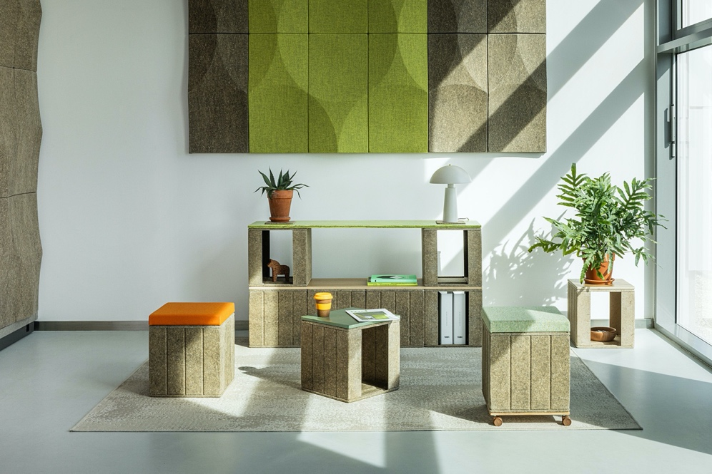

Building is for everyone! Experience biodesign - new VANK_CUBE collection

A new player has entered the market - a biomaterial-based form named VANK_CUBE. It was presented for the first time at ORGATEC 2022 in Cologne as an alternative to a traditional storage box made of wood or plastic. A single module resembles a box, but the system can be used as a desk, a meeting table, a front desk, a shelf, or a storage space divider. The modular system is now available for purchase!

VANK_CUBE is a modular system of cubes made of flax and hemp biomaterial that makes it possible to set up an eco-friendly workspace for any size and purpose - and rearrange it easily. It also brings the ever in-demand flexibility to co-working spaces, event and trade show venues, start-ups, cafés or educational institutions when interior customisability comes into play. Thanks to the natural material and colour scheme, it will be a great choice for both those into minimalism and into japandi or boho.

The possibility of furnishing an office the agile way, in line with the office everywhere concept, became especially important during the health crisis and has since remained a mainstay of the hybrid work model. It aims to create a flexible and user-friendly workspace that fosters creativity, collaboration, and employee well-being. The system, based on a lightweight cube made of biomaterial, offers the opportunity to easily arrange offices and co-working spaces according to the changing needs of not only the user, but also the entire organisation. This feature is particularly important when the size of the leased space, the number of employees and clients, the functions of individual rooms, and the general arrangement of the office change frequently. Incorporating the system into well-established and rigidly structured companies makes it possible to break down hierarchies and blur the lines between individual departments. The easy assembly and disassembly means the possibility to set up temporary workstations or exhibition spaces at trade shows, conferences, and workshops.

Modularity means that a number of CUBES put together can be used as a desk, a workshop meeting table, a front office desk, a storage unit, a shelf for household appliances, or a space-dividing unit. Thanks to the flexible ‘building block’ and a set of dedicated connectors and fasteners, it is possible to create many different furniture forms and modify them as necessary virtually without limits. It takes only a few moments to transform a set of desks into an event setting: a meeting area with seats, a front desk, a bar, or a project space with high meeting tables, a lectern, and shelving units.

The design supports creative teams, social interaction, the art of improvisation, and the culture of collaboration, but also lets individualists working remotely do their job in a fun environment — it’s compact and lightweight home office equipment.
The infinite number of module functions translates into vibrant, fanciful spaces that resemble a playroom and encourage dynamic problem solving. Interior designers and users can create new forms and turn existing furniture into original, imaginative compositions. This is made possible thanks to the multitude of elements that complement the cube, including tops, fasteners and connectors, side panels, and plates made of VANK_BIO biomaterial, a base with castors or an upholstered seat cushion. Narrow, lightweight tops with depths to match the dimensions of a single CUBE unit are made of hardwood plywood with oak veneer and optionally coated with water-based varnish in green, orange or violet.
CUBE offers a very useful storage function — the user can decide whether to expose or cover the items kept on the shelf by changing the direction in which the cube faces or by using additional panels that also serve to stabilize the seat.

VANK_CUBE addresses the expectations of new generations, who value offices being designed and furnished with concern for the environment and with reduced CO₂ emissions in mind. This is consistent with the individual values that the new generation considers important, and is one of the main non-wage factors for young jobseekers.
CUBE units are manufactured with the application of modern technology making use of a biocomposite based on soft flax and hemp fibers. These plants absorb CO₂ from the atmosphere during their growth phase and convert it into biomass through photosynthesis. CUBE is therefore a product with a much smaller carbon footprint than other storage systems or typical office furniture. In addition, it is based on fast-growing fibrous plants that are annually renewable, do not require irrigation or fertilization, and are safe and human-friendly due to their natural origin. Thus, it is a collection designed in accordance with the principles of sustainable growth, contributing to the development of the circular economy and the use of renewable bio-resources.
VANK_CUBE has been awarded a Special Mention in the Excellence in Business to Business — Office Solutions category in the German Innovation Award 2023 competition.

Design: Anna Vonhausen
VANK
VANK is a Polish team of architects, engineers, and artisans. We create furniture. Objects. Tangible signs in space. Items designed intelligently, with respect for the natural environment, and manufactured using the latest technologies. We believe in a circular economy model that limits the consumption of natural resources, reduces the amount of waste generated, and increases the use of biodegradable, renewable, and recyclable materials. We’re all about high quality, taking responsibility for what we do and make, and making our products last as long as possible.
IMAGES
PR CONTACT:
Natalia Sochacka, Marketing & Communications Manager,
natalia.sochacka@vank.design, + 48 601 553 221

