Poznań, September 8, 2023
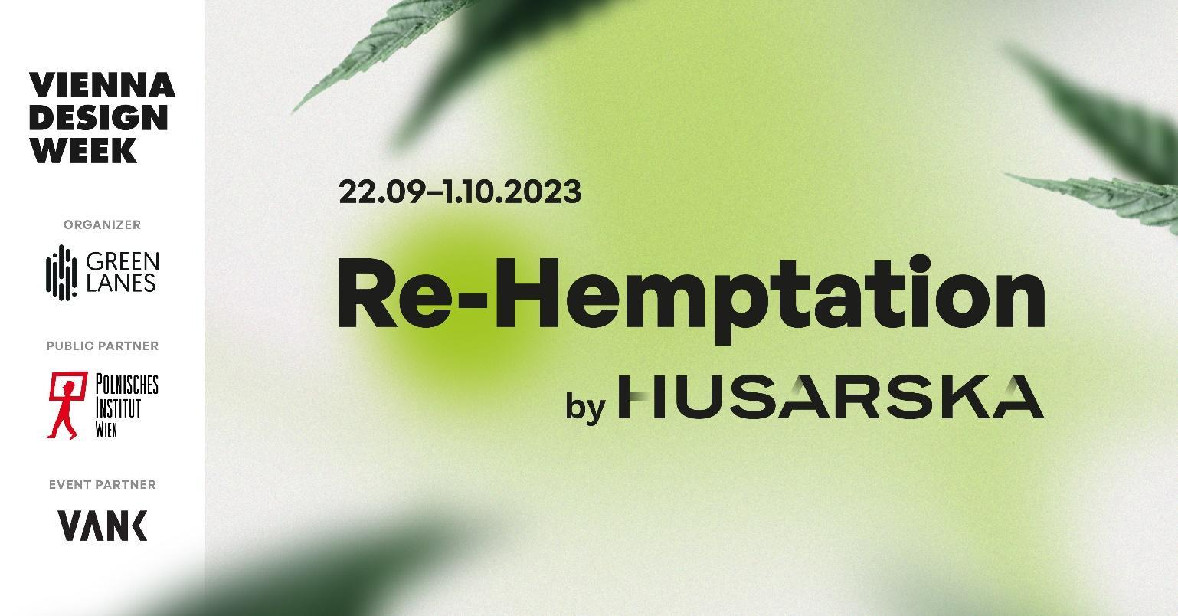
"RE-HEMPATION EXHIBITION AT VIENNA DESIGN WEEK 2023 - REDISCOVERING THE POTENTIAL OF ANNUAL PLANTS FOR A SUSTAINABLE FUTURE.
During this year's edition of Vienna Design Week 2023 , a revolutionary exhibition will be unveiled, showcasing the potential of hemp, flax, and other annual plants as ecological alternatives to traditional materials used in the timber, furniture, and food sectors. The exhibition responds to the environmental crisis and presents pioneering technologies developed by Green Lanes and VANK in collaboration with Husarska Design. These technologies allow for the use of annual plants in furniture production, interior finishes, and construction while simultaneously providing raw materials for other industries such as food, textiles, and nutraceuticals.
Due to their rapid regenerative capacities and ecological properties, annual plants represent an ideal raw material for a future grounded in the principles of sustainable development and circularity. The exhibition, titled "Re-Hemptation", showcases a diverse array of applications for annual plants, such as hemp and flax, in furniture, food production, protein, and other consumer goods. "Re-Hemptation" is the innovative creation of Husarska Design Studio. Co-organizing the exhibition is Green Lanes, which includes companies like The True Green, Green Lanes Proteins, Hempeat, and East Hemp Agriculture. The exhibition is open for visits from September 22nd to October 1st, 2023, at the main VIENNA DESIGN WEEK building located at Laufbergergasse 12 in Vienna. Key exhibition partners are the Polish Institute in Vienna, and VANK, a sustainable furniture manufacturer.
Visitors to our exhibition will be able to explore our innovative products that replace solid wood in furniture - says Piotr Pietras, CEO of Green Lanes. Husarska Design Studio designed the first furniture pieces made from hemp lumber: the Hempden table, Hempsquare bench, and the HempStool, which will premiere in Vienna. Our partner, VANK furniture manufacturer, will also present the VANK CUBE modular system made from a flax and hemp biocomposite. We believe that, just like during the European Economic Congress or the Łódź Design Festival where we showcased the first models, our solutions in Vienna will be received with equal enthusiasm.
Hemp lumber patented and produced by The True Green can replace solid wood in furniture, and we are showcasing the first models that use this revolutionary material - adds Jadwiga Husarska-Sobina from Husarska Design Studio. The exhibition is therefore a perfect proposal for architects, designers, influencers, and the general public interested in sustainable development, ecology, and innovation. We believe that Re-Hemptation will inspire further exploration and the development of innovations based on an ecological approach. We trust it will change the perception of hemp and flax, supporting the growth of sustainable solutions for our planet.
ACCOMPANYING EVENTS – MEETING THE EXHIBITION CREATORS AND HEMPEAT TASTING (PLANT-BASED MEAT ALTERNATIVE)
Two accompanying events will take place during the festival, offering opportunities to meet and discuss working with hemp materials. The first is Hemp Talk (23.09.2023 at the main festival building booth), a meeting with the exhibition's creators, designers, and producers. The second, Hemp Evening (25.09.2023 at the Polish Institute in Vienna), is a panel discussion dedicated to the use of hemp in the industry and the potential of annual plants in the context of challenges posed by the European Green Deal. Panelists will include Jadwiga Husarska-Sobina from Husarska Design Studio, Natalia Sochacka from VANK, Jacek Kramarz, Board Member of EIHA - European Industrial Hemp Association, Vice President of Green Lanes, and the Founder of Hempeat. The discussion will be moderated by Michał Piernikowski from the Łódź Design Festival. The meeting will also feature a tasting of Hempeat - a plant-based meat alternative. For Hemp Evening participants, a special exhibition showcasing raw hemp materials and finished products, including furniture from The True Green, will be available.
WHY IS THE EXHIBITION TITLED “RE-HEMPTATION”?
The title reveals the deeper meaning of the exhibition, focusing on the rehabilitation and reconstruction of the environment using hemp and promoting sustainable development and biodiversity protection. "Re-Hemptation" combines "re-" (renew, restore) with "hemptation" (from English: hemp). In terms of environmental renewal, the exhibition's name refers to the concept of restoring balance and reconstructing the natural environment through the use of hemp and other fibrous plants. Hemp has the potential to improve soil quality, purify water, and reduce pollution, contributing to ecosystem renewal and reconstruction. The dimension of rehabilitation suggests rehabilitating plants, including hemp, used as ecological alternatives to traditional materials. By promoting these plants, the exhibition emphasizes biodiversity protection and restoration of natural processes and cycles in ecosystems. Regarding sustainable development, "Re-Hemptation" also refers to the idea of sustainable development and a circular economy where innovations and new materials, like hemp, play a key role. The exhibition focuses on exploring the potential of hemp and flax as ecological alternatives to traditional materials while also promoting sustainable economic growth and the protection of biodiversity.
VANK
VANK is a Polish team of architects, engineers, and artisans. They specialize in crafting furniture and other objects that serve as tangible markers in space. Each item is thoughtfully designed, emphasizing respect for the natural environment and leveraging cutting-edge technologies in its creation. With a firm belief in the circular economy, VANK focuses on minimizing the consumption of natural resources, reducing waste, and maximizing the use of biodegradable, renewable, and recyclable materials. Their commitment is evident in the superior quality of their products, their sense of responsibility, and their dedication to ensuring product longevity.
During Vienna Design Week VANK is presenting a novelty, another sustainable form made of biomaterial - VANK_CUBE designed by Anna Vonhausen. It's a modular cube system that allows the user to configure and reconfigure an eco-friendly workspace in any space and indefinitely. It gives the ability to easily change the interior according to changing needs. A single module looks like a box, but a system of modules can be a desk with a pouffe, a meeting table, a counter, a shelf, a bookcase or a lectern. CUBE is available in two natural colors light- and dark beige and has a storage function - the user can decide whether to expose or cover things on the shelf by changing the direction of the cube. The collection supports creative teams and a culture of collective work, but also allows individualists working independently at a distance to have fun.
SUSTAINABLE DESIGN - JADWIGA HUSARSKA – SOBINA & HUSARSKA DESIGN STUDIO
Experienced project manager and specialist in coordinating the launch of new products. Since 2014, she has been running the Husarska Design Studio in Krakow. She is a graduate and consultant at the Faculty of Industrial Design of the Academy of Fine Arts in Krakow. She studied design at the Lahti Institute of Design in Finland and at MOME in Budapest. She worked as a product development director at Paged Furniture, coordinating the work of design teams and engineers in product implementations for global clients. She designed for Nowy Styl Group, SanSwiss, Apus Sports, Total Fitness Concept, and FlooredMedia (projects for IKEA). She was honored by UNDP with the title "Angel of Social Economy" for supporting the development of the WellDone brand on behalf of the Być Razem Foundation. She has more than 195 successful implementations across various business sectors to her credit. She is the recipient of many Polish and international awards, including 5 RedDot awards, which are considered the "Oscar" in the field of design.
GREEN LANES - the company with a positive impact. In its portfolio, it has independent entities focused on the development of projects and technologies in the industry focused on processing annual plants, including fibrous hemp. Currently, Green Lanes is developing three portfolio companies: The True Green, Green Lanes Proteins, and Hempeat. In 2024, the company plans to go public.

PRESS MATERIALS
a) LOGOS and IMAGES
https://drive.google.com/drive/folders/1Jxj6ua5CrirTij8ziy5coLYdZmT1CiY0?usp=sharing
WEBSITE ADDRESSES:
a) www.greenlanes.pl b)www.glproteins.com c)www.thetruegreen.world
d) www.husarska.com e) https://vank.design/en
f) https://instytutpolski.pl/wien/pl/2023/08/09/vienna-design-week-re-hemptation-2/
STATEMENT: All submitted materials are the property of Green Lanes, Husarska Design Studio, and VANK, constitute press materials, and have permission for their publication.

Natalia Sochacka, natalia.sochacka@vank.design, + 48 601 553 221

