Poznan, 23.04.2024

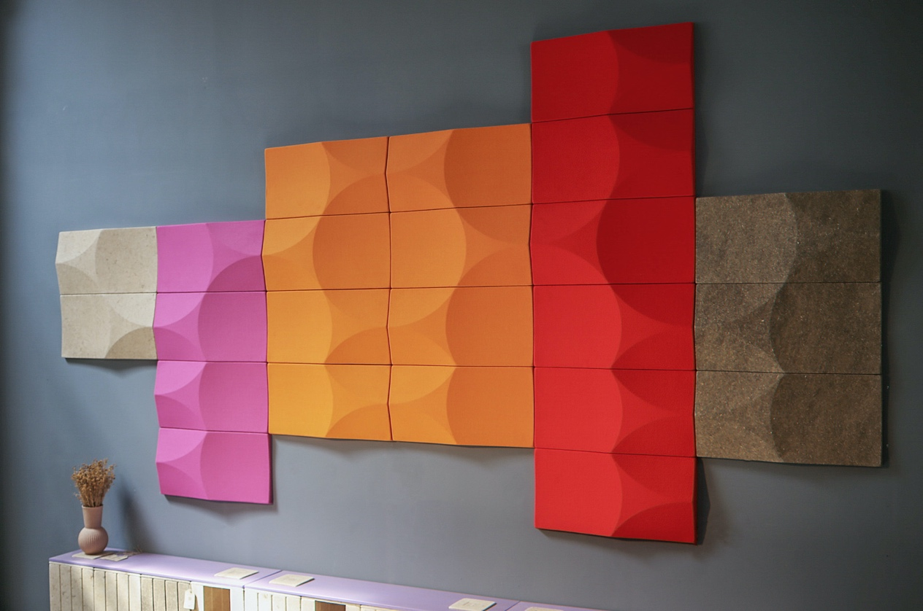

**VANK's debut at Milan Design Week: fusing sustainability with innovative design**

**VANK participated for the first time in the largest design event in the world: Milan Design Week, which took place from 15 to 21 April. Our sustainable designs were displayed in the exhibition organised by the Italian Isola Design group and situated in a revitalized venue with green DNA - Lampo Milano, located in the vibrant Isola district.**

There was a resounding emphasis on sustainability and a compelling call to action at this year’s **Isola Design Festival.** As an integral part of Milan Design Week, the eighth edition championed the theme ***This Future is Currently Unavailable*** urging designers to confront pressing real-world challenges. Under this theme, Isola invited exhibitors to present forward-thinking concepts that intertwine **innovation, sustainability, and craftsmanship**, highlighting the industry’s potential for the future. During the Isola Design Festival, over 320 global designers, studios, creatives, and manufacturers showcased their work in numerous venues, encompassing three main centers, notably, for the first time, the Lampo event venue situated at Via Valtellina 5. **Lampo Milano** - a main Isola Design hub during festival -is a new urban redevelopment project with green DNA spanning an area of 40.000 sqm within the historic railway yard, **Scalo Farini.**

**Is One Life Enough?**

The group exhibition ***Is One Life Enough?*** in Lampo featured a selection of designers exploring the reuse of products designed instead for a single life cycle. **Sustainability** was everywhere, from the pieces to the set-up. One of the partners in the event, provided recycled egg cartons as the base for the pedestals, other made the pedestal tops out of mycelium.

Our sustainable designs took center stage at the exhibition organized by the Isola Design group. Among our solutions were **acoustic wall panels** crafted from biomaterials or upholstered, offering vibrant and functional **acoustic reliefs**. Notably, we featured our award-winning **modular cube system VANK_CUBE,** also made from **biomaterials.** CUBE won the German Innovation Award 2023 and the OFFICE ROXX TOP100 2024 recognition, and was also shortlisted for the Mixology Award in 2023.

VANK exhibition explored the **idea of energy** as an integral element to innovative design, just as **solar energy** is essential for plant growth in the process of photosynthesis. Through this process, plants absorb carbon dioxide from the atmosphere and convert it into biomass, which we can then use in various creative and manufacturing processes. The greater the number of products featuring renewable plant-based raw materials, the lower the dependence on oil and the carbon footprint. This synergy between nature and creativity paves the way for new opportunities in sustainable development and creative approaches to design. For decoration, we used **live industrial hemp** from Italy, in collaboration with another Polish brand, The True Green.

**VANK LONG with Iconic Awards 2024**

During Milan Design Week we attended the **German Design Council** awards ceremony.Anna Vonhausen's new circular lounge chair with footrest,VANK_LONG, won the **Iconic Awards 2024** in the Interior Products category. It was presented in Milan in an additional digital exhibition at the gallery Amy-d Arte Spazio in the Brera district, Via Lovalio 6.

**Boucle fabric in sunset colors from Kvadrat**

The event in Milan was also the occasion for a further collaboration with **Kvadrat**, a renowned brand recognized for its high-quality premium fabrics, which we showcased on our **circular soft seating** collection. The soft-touch **boucle Elle** in sunset colors was featured on the VANK_LONG lounge chair, known for its distinctive line of semicircular cushions.

Our collections in Milan:

**[VANK_CUBE](https://vank.design/en/products/cube)** is a modular cube system crafted **from biomaterials**, that makes it possible to set up a truly green workspace in any environment and adapt it to the changing needs of its users. The designs fosters creative thinking and a culture of collaboration.

The CUBE elements are manufactured using innovative biocomposite made from **flax and hemp** — fast-growing renewable plants that absorb much more CO2 than trees. The CUBE by Anna Vonhausen secured the German Innovation Award 2023, earning the 10th spot in Office Roxx magazine's prestigious TOP100 list, and emerged as a finalist in the Mixology North 2023 competition.

VANK’s state-of-the-art [**acoustic walls panels**](https://vank.design/en/products/acoustic-panels-and-walls) are a combination of pro-environmental values and every individual’s need for [wellbeing](https://vank.design/en/wellbioing). Our proprietary technology makes use of **renewable materials**, and produces shapes that provide sound attenuation and make rooms soundproof. Designers have the freedom to configure panels of various shapes, allowing for the creation of imaginative wall finishes in both public spaces and homes. The project is a finalist for the German Sustainability Award 2022 and has been honored as the winner of both the Green Product Award 2022 and the Iconic Awards 2022.

By utilizing plant-based raw materials, VANK minimizes the reliance on petroleum-based substances, thereby contributing to the circular economy and the combat against the climate crisis.

The VANK_BIO raw material has a **negative carbon footprint**. Bio-based resources - such as flax and hemp - absorb CO2 from the atmosphere during their growth phase and convert it into biomass through photosynthesis. The quick growth of hemp, i.e. up to even 4 metres in 100 days, makes it one of the fastest CO2 absorbers out there. A hemp field can absorb up to 15 tones of CO2 per hectare (according to IPCC reports).

[**VANK_LONG**](https://vank.design/en/product/long-armchairs) is a line of eye-catching industrial-style furniture, that draw inspiration from Bauhaus minimalism. The seat, resting on flexible upholstery straps undoubtedly, guarantees a special user experience and a high level of well-being. This **sustainable collection** makes use of organic latex filling. The design allows easy disassembly and recycling of components after use. The collection is modular - fasteners and connectors make it possible for the user to use armchairs to put together sofas as well as endless rows of seats. Their base is a black metal frame that emphasises their industrial character.

[**IMAGES**](https://www.dropbox.com/scl/fo/9fuwna8ihghv04sc0sqvj/AHuWbHFhvsVnCW7lKqTL_pk?rlkey=o4iaci2fv5zia9d785go4njef&st=lz95q9pi&dl=0)

**WHAT THE** [**VANK**](https://vank.design/pl/start)

VANK is a Polish team of architects, engineers, and artisans. We create furniture. Objects. Tangible signs in space. Items designed intelligently, with respect for the natural environment, and manufactured using the latest technologies. We believe in a circular economy model that limits the consumption of natural resources, reduces the amount of waste generated, and increases the use of biodegradable, renewable, and recyclable materials. We’re all about high quality, taking responsibility for what we do and make, and making our products last as long as possible.

[www.vank.design](http://www.vank.design) |  [Linkedin](https://pl.linkedin.com/company/vank) |  [Facebook](https://www.facebook.com/VANK.interior.objects) | [Instagram](https://www.instagram.com/vank_interior_objects) |  [YouTube](https://www.youtube.com/channel/UCTJucAM22uMZ3wYGUiG2fpQ/videos) |  [Pinterest](https://pl.pinterest.com/vank_funky_interior_objects)

**For media inquiries and additional information, please contact:**

Natalia Sochacka, Marketing & Communications Manager,

natalia.sochacka@vank.design, + 48 601 553 221